14-4: Helping Students See the “Big Picture” of Variance Analysis by Neal VanZante

Variances, or the differences between budgeted, planned, or standard amounts and the actual amounts incurred or sold, are a critical part of management accounting. They give managers a basis for making informed decisions, yet many accounting students have difficulty with variance analysis. Part of this difficulty may be caused by the manner in which this topic is typically presented in cost/managerial accounting textbooks. Some textbook coverage is disjointed, with brief mentions of flexible budget variances just prior to discussing manufacturing cost variances. Then, in a much later chapter, salesvariance analysis may be covered with little or no reference to the earlier sections. Discussion of input mix and yield variances may be presented in appendices, if at all.

In addition to these disjointed presentations, textbook coverage is often heavily formula driven, offering no alternative methodology. Although some textbooks provide overview tables (and problems) showing the interrelationships of the variances in a particular chapter, comprehensive coverage of variances in the entire textbook is lacking. In other words, there is typically no discussion of how variances covered in earlier chapters may be incorporated with the variances covered in the later chapters. Thus, many students fail to see how they are related, as well as the similarities between the computational aspects of some of the variances.
In my senior/graduate-level Advanced Cost/ Managerial Accounting course, I use two cases to help students better understand variance analysis. The cases allow students to see the “big picture” without being overly complex. While students are required to calculate all variances typically presented in cost/ managerial textbooks, they are continuously reminded of the
numerous similarities in the computational aspects of these variances. Furthermore, they learn—and understand—alternative methods for computing variances and presenting their solutions. The first case requires students to calculate all the traditional sales variances and the “flexible budget” variances for the Fernandez Company, which manufactures three types of fine pool cues: good, better, and best. The only difference is the materials used in their production.

The second case requires the calculation of materials price, mix, and yield variances for the Roger Company, which uses materials X, Y, and Z to manufacture Product NRV. The exercise concludes with a summary of the variances in both cases.
THE FERNANDEZ COMPANY
The Fernandez case (Table 1) has five parts. Part 1 requires students to make several detailed calculations in a table similar to those usually included in textbook coverage of flexible budgeting. The Fernandez Company table, however, has additional columns to incorporate the sales mix variance and rows for both variable and fixed operating expenses. Because accurate completion of this table is vital for students to fulfill and better understand the remaining requirements, I provide “check figures” and “help” as necessary to ensure successful completion. Students may complete the table manually, but I encourage them to use a spreadsheet package so they may clearly observe the computational similarities of each number and, thus, are better prepared to understand the differences. Students comfortable with a spreadsheet package tend to use the copy command and then revise the formulas as needed. The completed table appears in Table 2.

Sales Volume, Sales Mix, and Sales Quantity Variances
Part 2 of the Fernandez case requires students to detail the calculation of the variances.

The sales volume variance is equal to the difference of contribution margin between the flexible budget (based on actual sales mix) and the static budget (based on original budgeted sales mix). In Table 2, it is simply the difference between the contribution margins (and incomes) in the third column (actual mix at budgeted dollars) and the seventh column (the static budget). The volume variance may be broken down into a mix variance (column three minus column five) and the quantity variance (column five minus column seven).

Some students calculate the respective weighted average contribution margins of $39.60 per unit (actual) and $36.00 per unit (budgeted). Using this information, the solution of the volume variance, mix variance, and quantity variance is presented in Table 3.

The amounts, of course, agree with those in the solution to Part 1. Students observe that all variable items (sales and all variable costs) increase by 10% because the “quantity” increases by 10%. Some students will explain the “mix” variance in a little more detail, noting that the $6.00 ($106.00 – $100.00) increase in the average budgeted sales price times 110,000 units equals the $660,000 sales difference. The variable operating expenses increase of $0.60 (for the 10% sales commissions based on the higher average price) times 110,000 equals the $60,000 variable operating expense difference; and the $1.80 increase in the average budgeted cost of materials due to the change in sales mix times 110,000 equals the $198,000 increase in materials cost. These differences account for the $3.60 per unit increase ($6.00 – $0.60 – $1.80) in average budgeted contribution margin. Table 4 shows another approach; it is not necessarily simpler, but it gives students a better view of the underlying cause of the mix variance.
Sales Price Variance

The sales price variance is the $341,000 at the top of the flexible budget variance column in Table 2. It is the difference between the actual sales (in the actual mix at the actual prices) and the budgeted sales (in the actual mix at the budgeted prices). Students are provided with the actual average selling price ($109.10) and the average budgeted selling price based on the actual mix ($106). The $341,000 sales price variance comes from the difference between these two averages ($3.10) multiplied by 110,000 units. You could also require students to calculate this variance by multiplying the individual differences in actual and budgeted sales prices times the actual number of units sold and then have them prove the mathematical equivalency of the two approaches.

Materials and Labor Variances

The total materials variance may be broken down between price and efficiency (quantity) differences. While most textbooks present these horizontally, I typically present them vertically, with the actual quantity and prices on top (using the same format as with the sales mix and quantity variances.) Because the calculations involve costs, positive differences reflect unfavorable variances, and negative differences reflect favorable variances. The unfavorable material variance in Table 2 ($87,725) is explained in Table 5.

The labor variance can be presented using the same format as the material variances. Table 6 illustrates the $33,000 favorable labor variance.

Variable Overhead Variances

When manufacturing overhead is allocated on the basis of direct labor hours, the variable overhead efficiency variance will be consistent with the labor efficiency variance. A quick way to calculate the overhead efficiency variance is to multiply the labor efficiency variance by 7/25 (the budgeted variable overhead per hour divided by the budgeted labor rate per hour). In this case, the answer would be a favorable $38,500 ($137,500 × 7/25). Table 2 shows the total
variable overhead variance is $13,750 unfavorable. Thus, the variable overhead spending variance must be $52,250 unfavorable. The variable overhead variances can be shown in a format similar to the materials and labor variances as in Table 7.

Fixed Overhead Variances

The fixed overhead spending variance is typically the easiest to compute because both the actual amount and budgeted amount are known; it is simply a matter of subtracting. In the Fernandez case, the actual fixed overhead is $2,150,000, and the budgeted fixed overhead is $2,000,000. The difference of $150,000 is the unfavorable fixed overhead spending variance.
The fixed overhead volume variance represents the under (over) applied fixed overhead. It can be calculated easily by multiplying the budgeted fixed overhead by the percentage difference in the number of actual units sold and the original number of units originally predicted. If units produced exceed the original budget, the variance is favorable (more fixed overhead costs allocated than planned) and vice versa. Thus, the fixed overhead volume variance in this case is $200,000 favorable ($2,000,000 x 10%). Because the volume variance in this case would be closed to cost of goods sold (or gross margin), this variance does not reflect a difference in the actual income and the static budget income.

Operating Expense Variances

In this case, variable operating expenses were larger than anticipated because of higher sales commissions associated with higher sales prices. Because the sales commissions were 10% of sales prices, the unfavorable variable operating expense variance of $34,100 is equal to 10% of the favorable sales price variance of $341,000. The fixed operating expense variance is similar to the fixed overhead spending variance: It is calculated by subtracting the budgeted fixed operating expenses from the actual fixed operating expenses. In this case, the unfavorable fixed operating expense spending variance is $50,000 ($1,050,000 – $1,000,000).

Part 3 of the Fernandez case requires students to summarize Parts 1 and 2. As previously noted, the fixed overhead volume variance is the only one not used in reconciling the difference between actual income and static budget income.

Market Size and Market Share Variances

Part 4 of the Fernandez Company case provides information about the budgeted market size (1,000,000 units) and the actual market size (880,000 units). Students are asked to compute the market size and market share variances.

Fernandez Company budgeted 100,000 units (10% of the budgeted market) but sold 110,000 units (12.5% of the actual market). Textbook solutions are traditionally much more complex than necessary. For example, using the data from this case, a typical solution would be:

Market share = Actual market size × (Actual market share –Budgeted market share) × Budgeted weighted average contribution margin per unit

= 880,000 × (0.125 – 0.10) × $36.00 = $792,000 favorable
Market size = (Actual market size – Budgeted market size) × Budgeted market share × Budgeted weighted average contribution margin per unit
= (880,000 – 1,000,000) × 0.10 × $36.00 = $432,000 unfavorable

Together the market share and market size variances account for the $360,000 favorable quantity variance. I prefer to simplify it by focusing on the causes of each variance. For example, one way to present it is:
Market share = (Actual sales in units – 10% of actual market) × $36.00 = (110,000 – 88,000) × $36.00 = 22,000 × $36.00 = $792,000 favorable
Market size = (10% of actual market – static budget units) × $36.00 = (88,000 – 100,000) × $36.00. = –12,000 × $36.00 = $432,000 unfavorable

Another way to present the variances is to note that the market size variance is simply 12% (the decline in market size) times $3,600,000 (the static budget contribution margin), or $432,000 unfavorable. The market share variance is 25% (the percentage increase in the market share from 10% to 12.5%) times $3,168,000 ($3,600,000 – $432,000).

An even simpler presentation, representing just a minor modification, is:

Actual units 110,000 Budgeted share of actual market (10% of 880,000) 88,000 Static budget units 100,000

The market share variance ($792,000 favorable) is simply the difference between the first two numbers (22,000) times the budgeted contribution margin ($36.00). Likewise, the market size variance is the difference between the second and third numbers times the budgeted contribution margin (-12,000 × $36.00 = $492,000 unfavorable).

Part 5 asks students to discuss computational similarities between the variances calculated and the calculations involved with strategic analysis of operating income (growth component, pricerecovery component, and productivity component). While strategic analysis is not “variance analysis” per se, certainly the computations involved in the growth and pricerecovery components, for example, are practically identical to the computations of the direct materials and direct labor efficiency and price variances. (I mention these again later when highlighting ways to increase or decrease the complexity of the cases.)
THE ROGER COMPANY
The Roger Company case (Table 8) is a straightforward problem involving the calculation of the materials price and efficiency variances, then breaking down the materials efficiency variance into the materials mix and
yield variances. I primarily use this case to provide alternative approaches to solving these types of problems and to demonstrate computational similarities with the Fernandez Company case. The information provided for the Roger Company case can be used to create Table 9.

In Table 9, the price variance is the difference between the total actual costs and the standard input costs for the actual mix: $56,732 – $55,120 = $1,612 unfavorable. The efficiency variance is the difference between the standard cost of the actual input and the standard cost of the actual output: $55,120 – $50,000 = $5,120 unfavorable. You can also calculate the total price variance by multiplying the actual input total by the difference in the actual and standard costs of the actual mix: 52,000 gallons times ($1.091 – $1.060), or 52,000 × $0.031 = $1,612.

Of course, you can present the price variance in the more traditional fashion by multiplying each of the inputs by the difference in price, as shown in Table 10.

The materials mix and yield variances can be calculated quite quickly by observing that the difference in the total input gallons and standard input gallons is 2,000 (52,000 – 50,000). Multiplying by the standard $1.00 average cost per gallon provides the unfavorable yield variance of $2,000. That means the mix variance must be $3,120 unfavorable ($5,120 efficiency – $2,000 yield). The mix variance can also be calculated by simply multiplying 52,000 by the difference in the average budgeted cost of the actual mix and the standard average budgeted costs: 52,000 × ($1.06 – $1.00) = $3,120 unfavorable. The more complete approach, which includes the individual causes of the mix variance, is shown in Table 11.

The more detailed approach to the mix variance is identical to the illustration of the detailed sales mix variance in the Fernandez Company case, and the calculations of the overall materials price variance is the same as for the sales price variance. The yield variance, using the weighted average standard budgeted cost per gallon, can be calculated in the same manner as the
Blocher, Stout, Juras, Smith: Cost Management, 8/e 14-36 Copyright © 2018 McGraw-Hill Education. All rights reserved. No reproduction or distribution without the prior written consent of McGraw-Hill Education.

materials efficiency variances as shown in the Fernandez case.
EXPOSING STUDENTS TO A VARIETY OF APPROACHES
Obviously, all alternative approaches to derive the correct answer must be mathematically equivalent, so I often demonstrate mathematical equivalency when presenting alternative solutions. Also keep in mind that you can easily revise the Fernandez case to increase its complexity:

• Students could be required to prove the mathematical equivalency of alternative methods and, perhaps, challenged to offer their own alternatives. • More labor variances could be added by including additional classes (and costs) of labor for each product and by having each product exhibit different efficiency variances for materials and labor. • Students may provide logical explanations of possible causes of individual variances. • Another requirement might be to label the “static budget” column as last year’s numbers, and then have students perform strategic profitability analysis.

Complexity can be reduced by assuming the Fernandez Company produces only one product, thus eliminating computations and discussions of the mix variances. The Roger Company case either can be expanded to include similar labor variances, or it can be eliminated.
WHAT DO STUDENTS THINK?
Overall student response to the two cases has been favorable. Students who struggled through the coverage of the flexible budget and product cost variances stated almost unanimously that they gained a better understanding by revisiting the material. While most agree that the cases are a lot of work they would prefer not to do, the majority appreciate being exposed to the “big picture” of variance analysis. The vast majority indicate the benefit exceeded their sacrifice. Table 12 summarizes the variances involved in the two cases.

Reactions to the alternative approaches are mixed. Many students prefer to learn (memorize) whatever approach is offered in their textbook and “not be confused” by optional methods, even if they are easier to apply. Others, especially those who recognize the mathematical equivalencies of the methods, tend to prefer the easier approaches. I believe students should be exposed to a variety of approaches. This makes them more capable to solve problems that are presented in a slightly different manner than in their textbook, which is very useful in the real world.
Neal VanZante, Ph.D., CMA, CFM, CPA, CFE, is a professor of accounting at Texas A&M UniversityKingsville. Starting in September, he will be a faculty member at the University of Texas Pan American, Edinburg, Texas. Neal can be contacted at (956) 3812406 or nealvz@stx.rr.com.

Blocher, Stout, Juras, Smith: Cost Management, 8/e 14-37 Copyright © 2018 McGraw-Hill Education. All rights reserved. No reproduction or distribution without the prior written consent of McGraw-Hill Education.

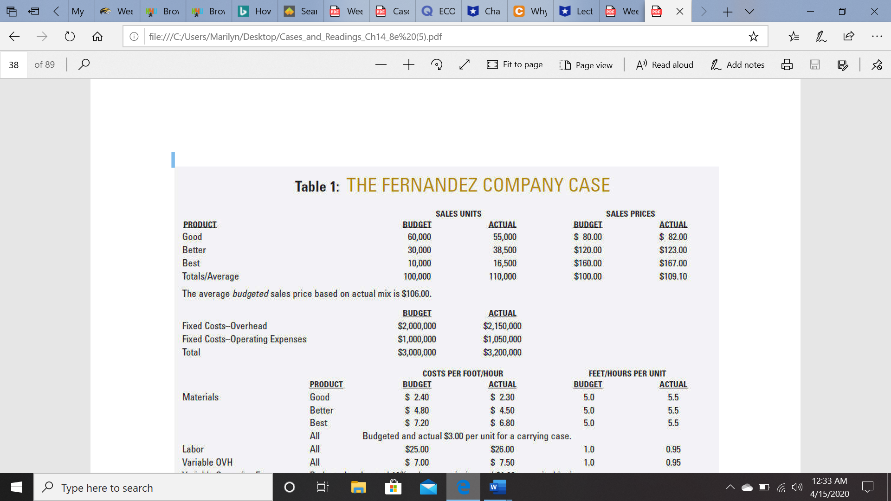

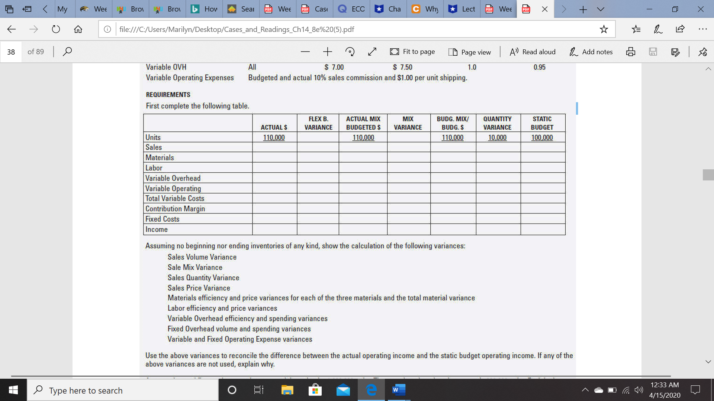

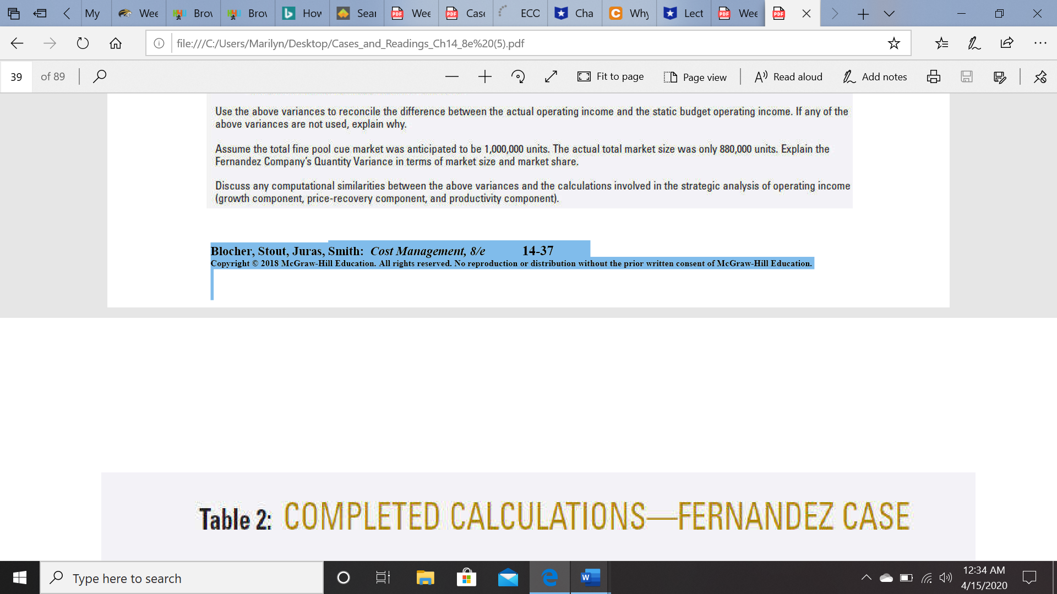

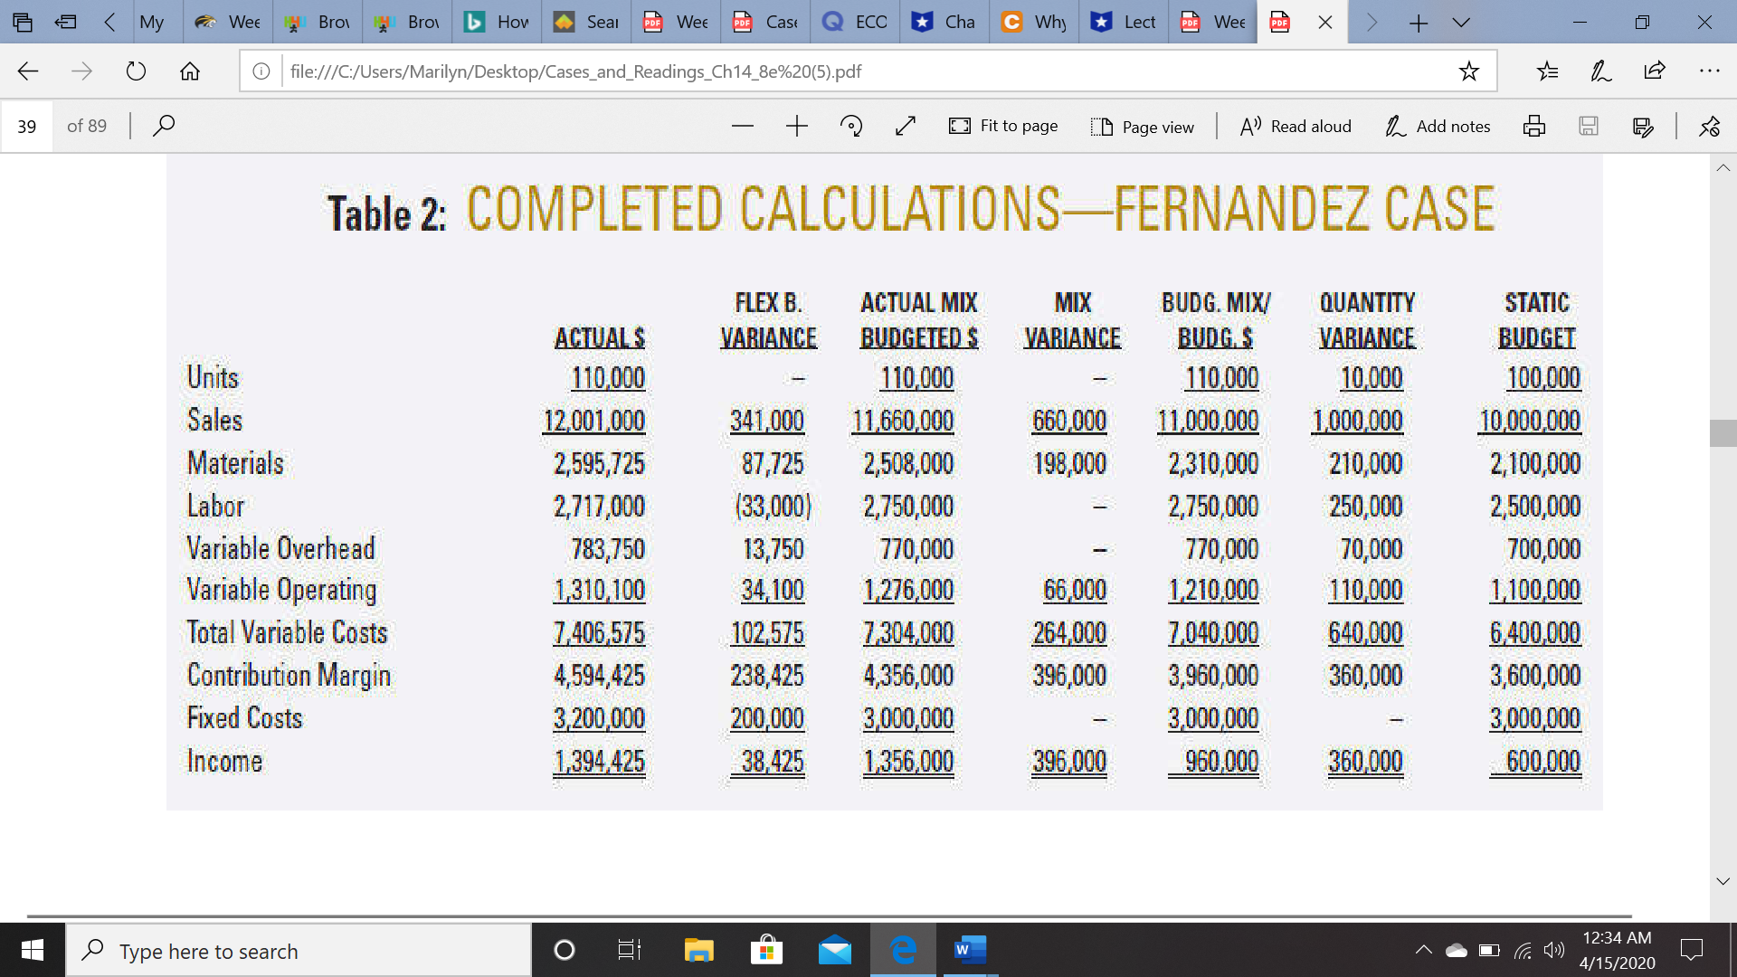

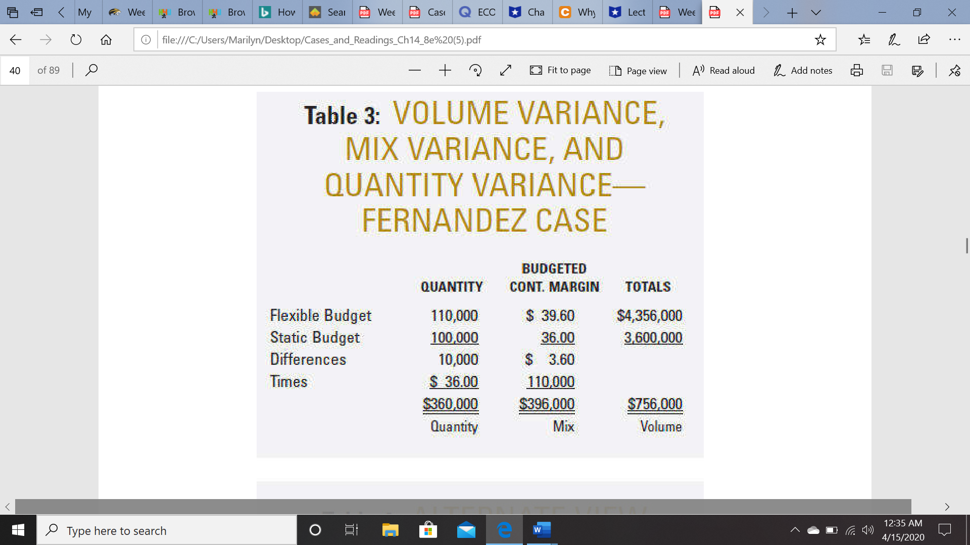

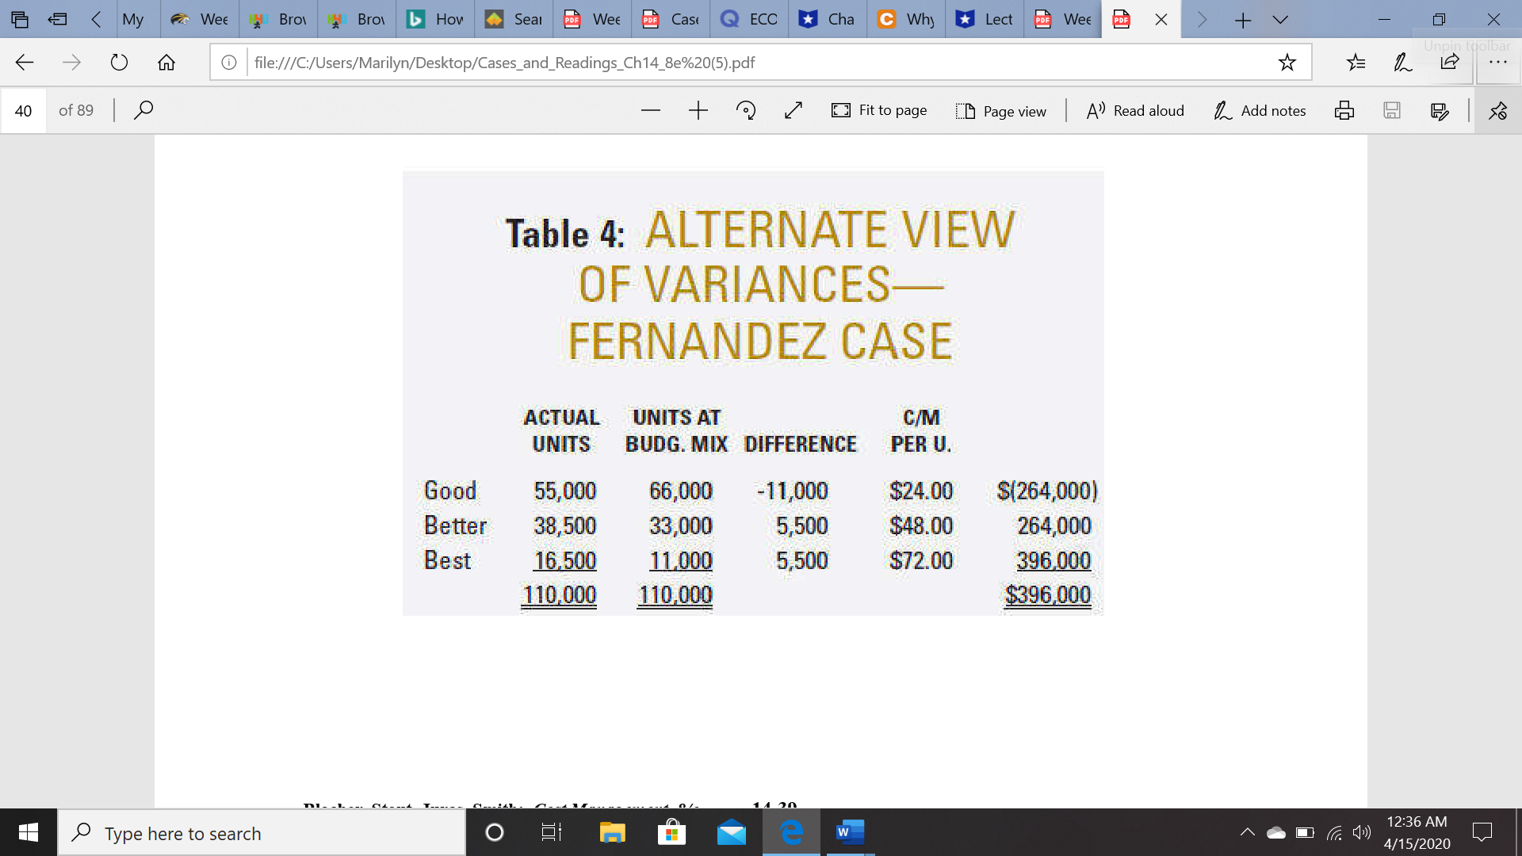

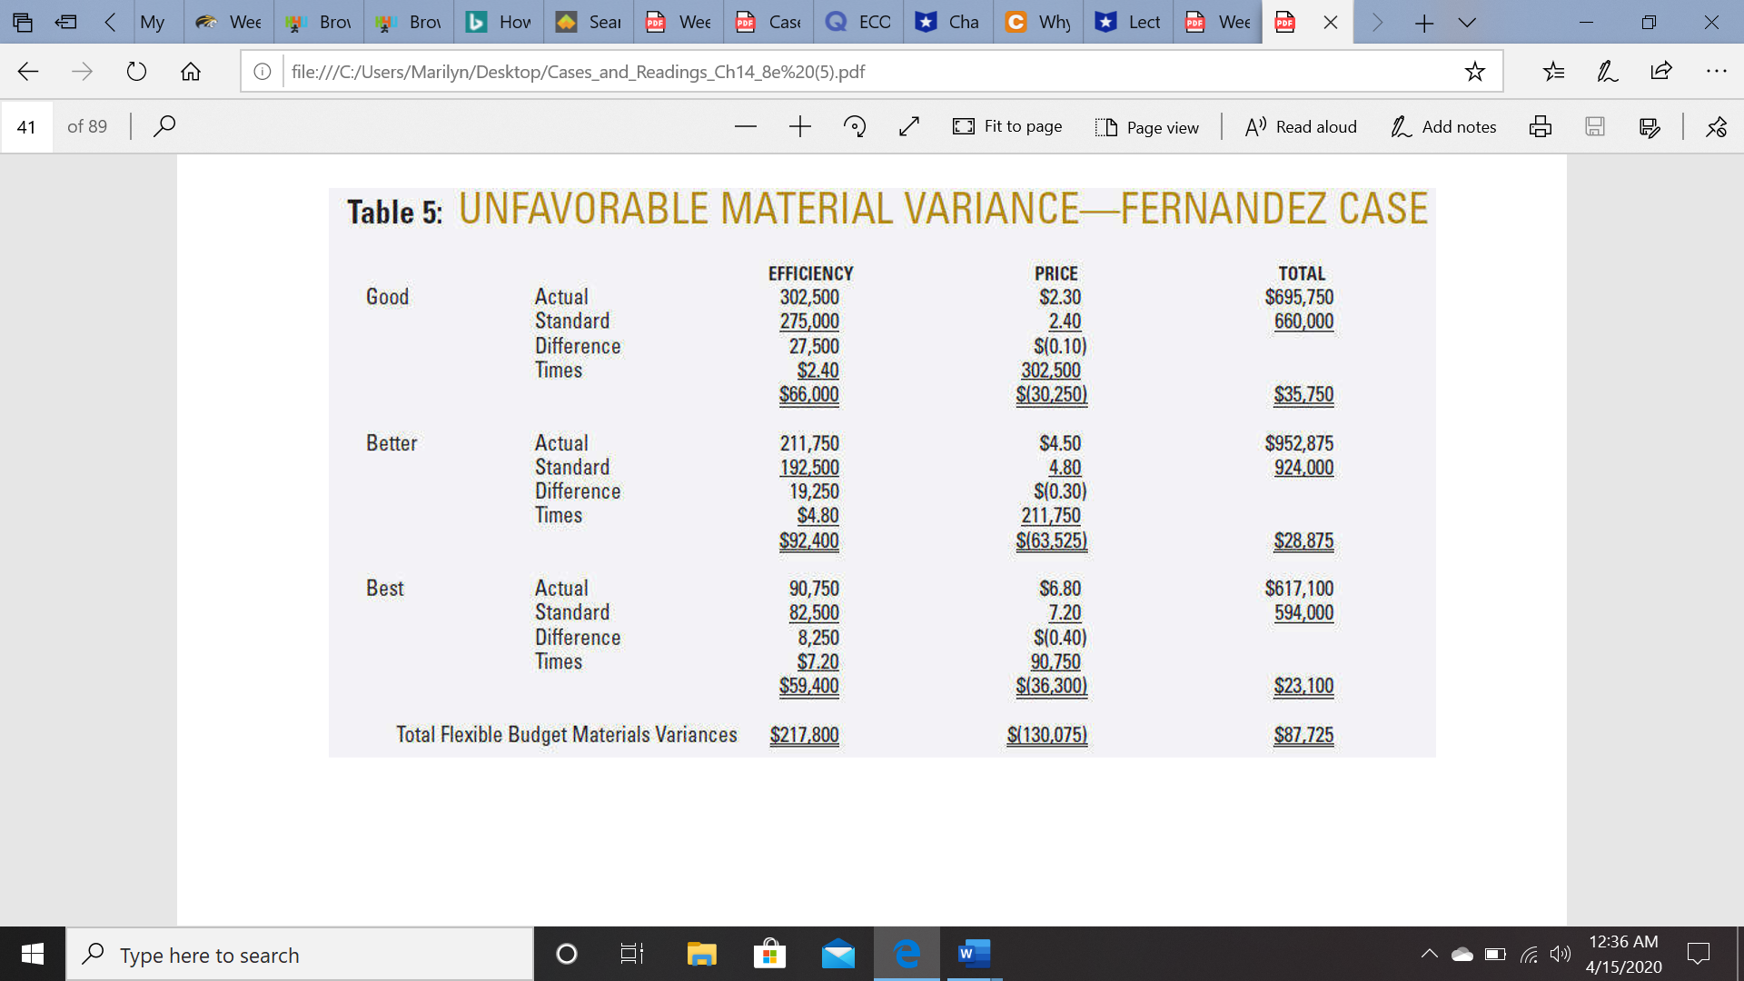

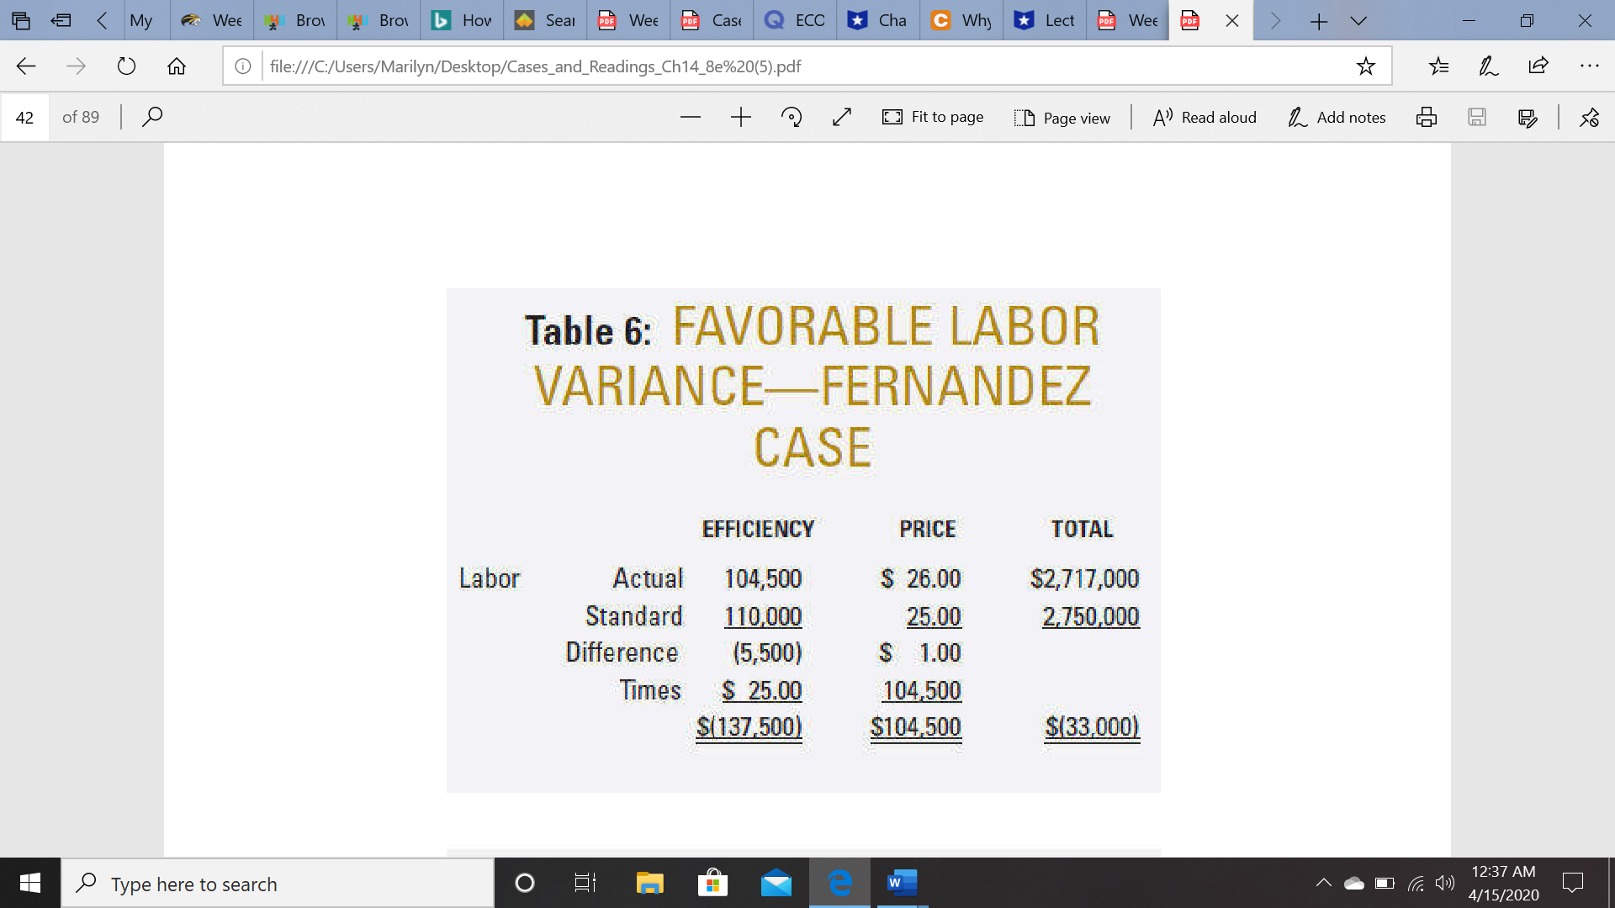

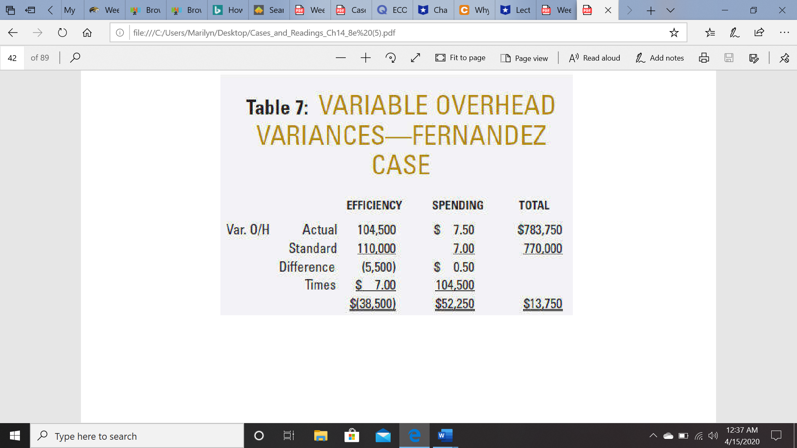

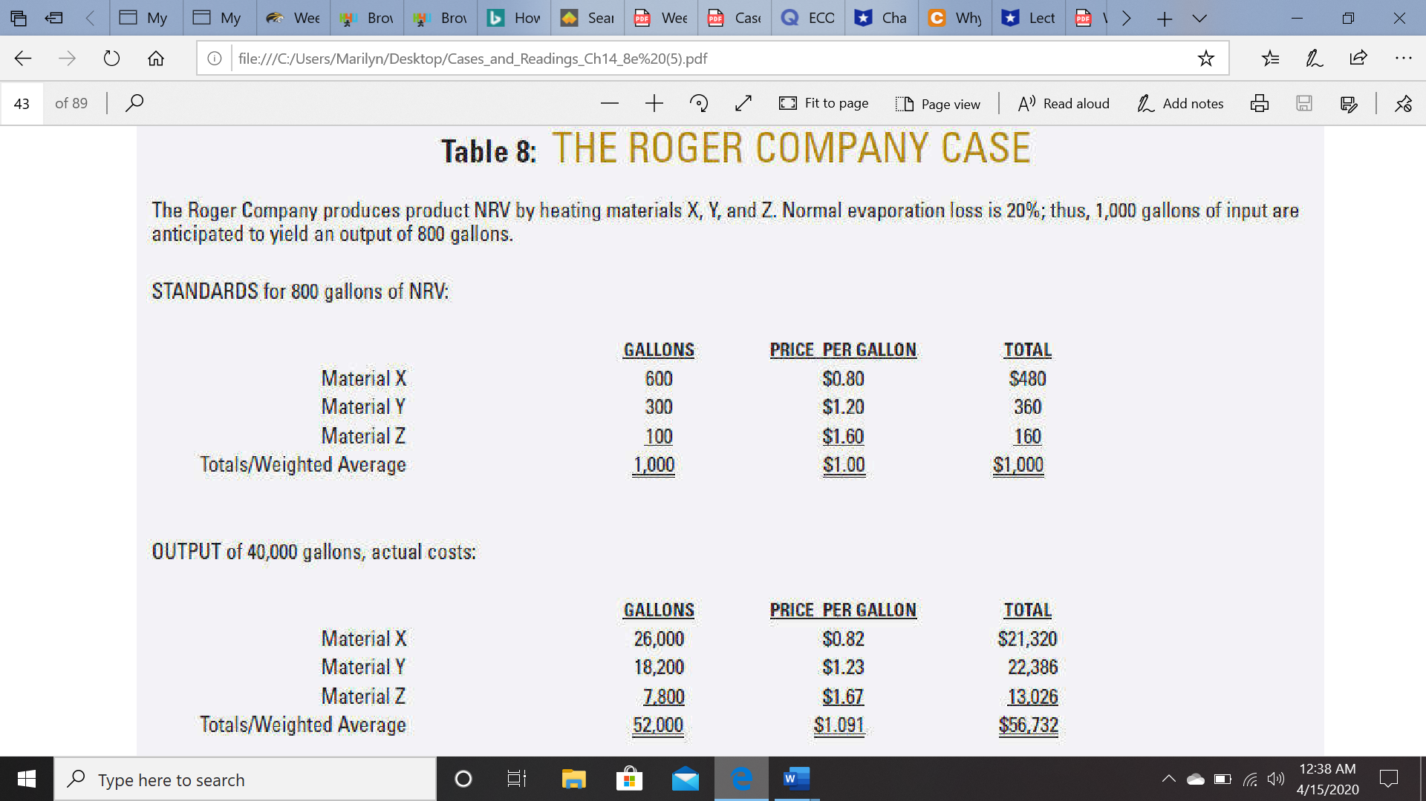
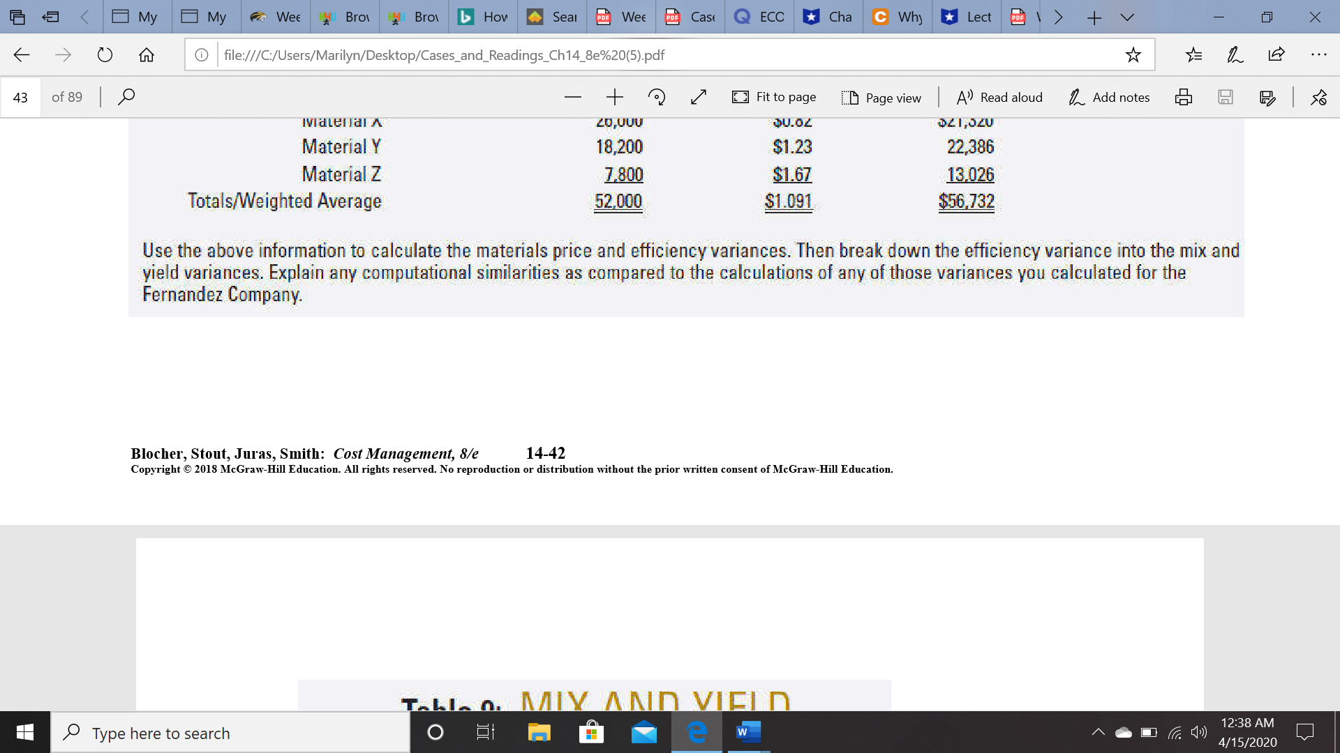
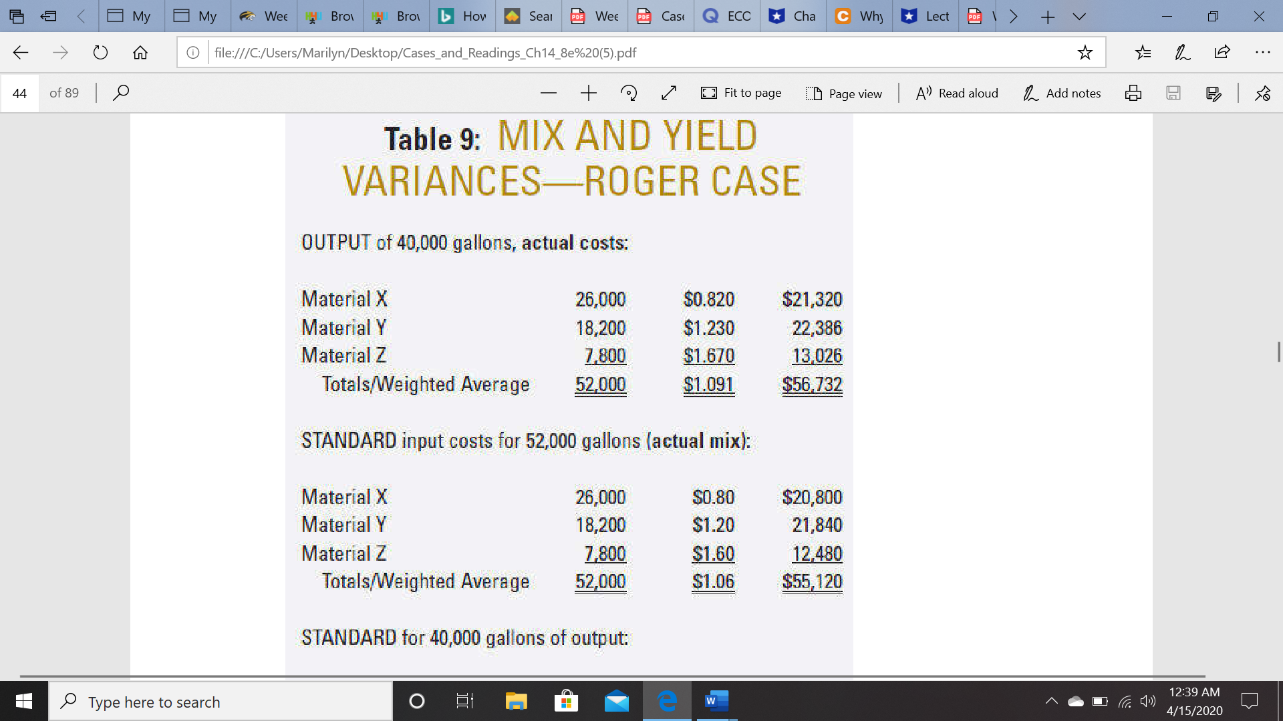

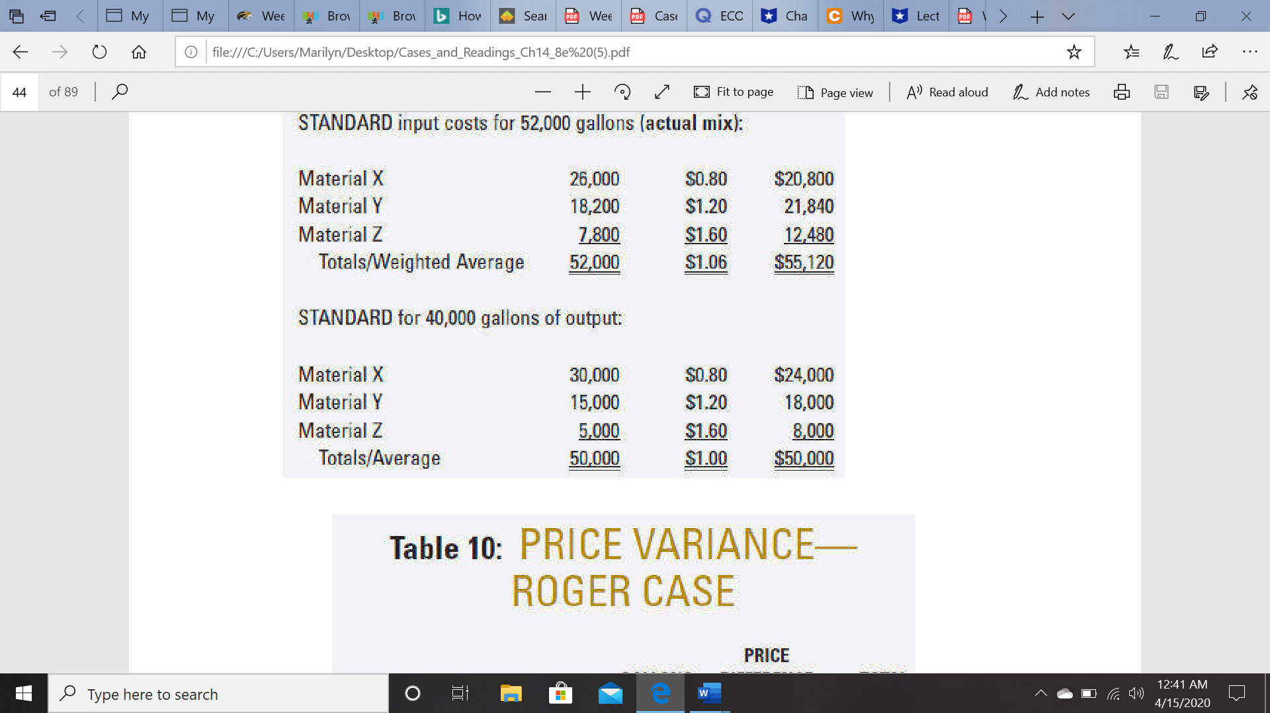

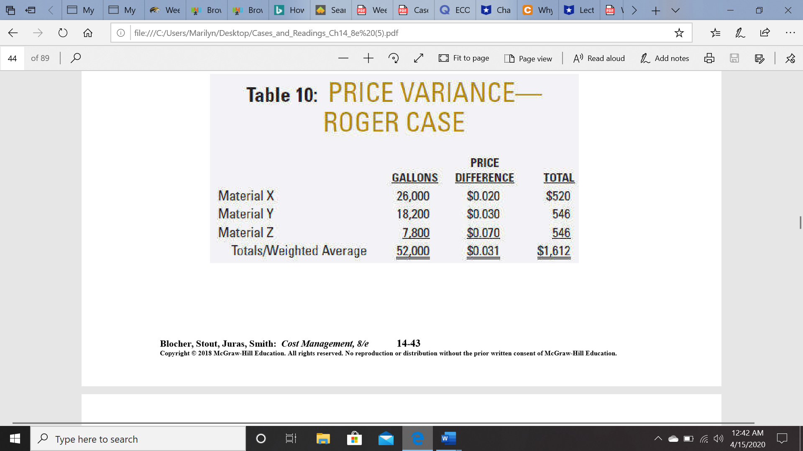

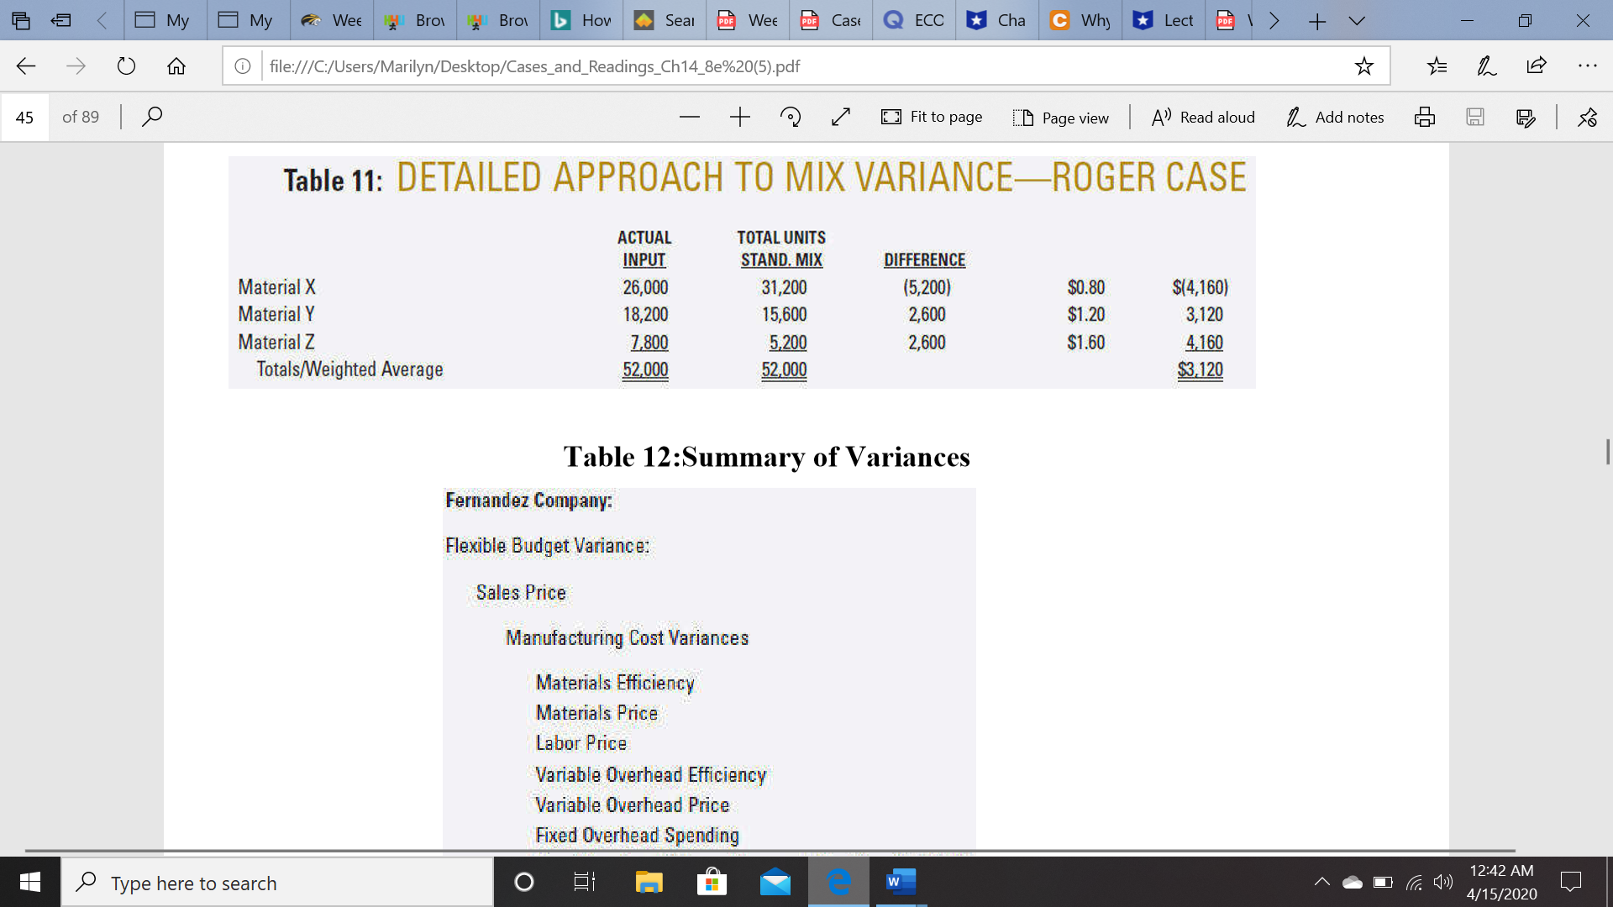

The Fernandez Company example requires students to first calculate the total flexible budget variance (in operating income) for a period and then breakdown this variance into its constituent parts (selling price variance, various cost variances, etc.). Use excel to do this and attach your files here.
After reading the article and both cases, answer the following questions.
Discussion Questions
1. What is meant by the total operating-income variance for a given accounting period? What alternative names are there to describe this variance.
2. What would be a first-level breakdown of the total variance described above in (1)?
3. How can the total flexible-budget variance be broken down (i.e., what are the constituent parts of this total variance)?
4. Explain the total sales volume variance for a period. How can this total variance be decomposed?
5. Explain the meaning of the joint price-quantity variance that is the basis for the discussion in the
Roger Company case. (Question 5 is 2 points Extra Credit)

